Process Improvement Opportunities: Nissan
Team B (Bea Guevarra, Chundra Womack , Corey Roberts, Emilio Montez)
ISCOM/472
04 September 2017
Rey De Puy

Introduction
The Nissan Motor Corporation is a Japanese operated motor vehicle company. Nissan is one of the top vehicle makers in the world. They are known for their high quality and durability in the vehicles that they manufacture. The Nissan mission statement is” Innovation and Excitement for everyone.” To Nissan this means making cars that are more efficient, more beautiful, more inspiring and more human than ever before. It also means, simply, making cars that change the world and the way we move through it. (nissanusa.com) Nissan is also well known for its diverse workplaces and its un-bias selection of leadership.
As-Is Process Flowcharts
Flowcharts are important for planning and working of a program or idea. Flowcharts are a type of diagram the shows a process by showing steps in boxes and connects them in order of sequence of how a plan should be accomplished. Flowcharts make it easier for a team to work together and decreases common mistakes that might be interpreted by someone just listening to instructions. Flowcharts are used for analyzing, designing, documenting or managing a process. Flowcharts have become a necessity because it develops a list of steps to solve problems with not a lot of confusion. The most two common boxes in flowcharts are an activity and a denoted box, that is the most common rectangular box. The final decision in a flowchart is usually as a diamond box.
Matrix Examples
Cycle time refers to the time taken from the beginning of a process to the end of a process. This involves all the time that is taken from when products and raw materials are brought together to be assembled to the time that all the products are made which also includes the assembling time and the time the that it has taken to bring all the products together. For Nissan Company, the organization has set up different plants that have helped up speed the manufacturing process. This has ensures that cars are manufactured as fast as possible as well as it has ensured the waiting process is reduced.
The car industry has been riddled with constant accusations that the models that are now being created are not top quality. For this reason, a lot of companies have put in efforts to ensure that the cars and the automobiles that they manufacture are up to the required standard. For Nissan Company the organization has invested in modern methods of production which ensures that the automobiles that are produced are top of the art. The company has also invested in research science which is important in improving the quality of the vehicles that they deal in with the company investing close to $100,000 in research every year to improve their car models(Toma & Marinescu, 2013).
Unlike other automobile companies, Nissan has put out recycling centers which have been helpful in ensuring that the scrap that comes from the manufacturing process as well as old cars returned by clients are properly recycled and put into good use. The company has also for a while been planning to create electric cars, which they are planning to launch soon which are environmental friendly.
To be able to reduce the operating costs that the company has been incurring the company has computerized its production processes. What this has been able to do is that it has cut down the costs of manufacturing that the company has been incurring. This is because the company has been able to reduce the number of employees that are working in its plants and this has helped bring down costs considerably.
Challenges
There are many challenges and difficulties to a company attempting to implement any major changes to the company structure. One major obstacle that Nissan will most likely face when trying to implement a new process improvement plan is getting all of the current employees to get on board. It is very easy to get new-hires to fall in line but, the older, original grandfathered in employees to follow suit. More times than not, grandfathered employees are usually accustom to what is already in place and are afraid on any type of change.

Two As-Is Process Improvements

As-Is Flowchart Figure 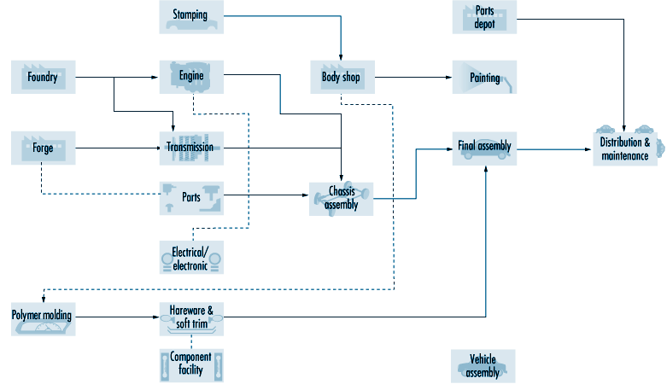

Conclusion
No matter the success of any company, there is always room for improvement. The first step from improvement is recognizing the issue. Once the issue is acknowledge the process can begin. Nissan and all other companies alike come up with various ideas to improve the success of the company. The As-Is process will help determine where they and how they are dealing with existing flaws.

Reference:
Toma, S., & Marinescu, P. (2013). Global Strategy: The Case of Nissan Motor Company. Procedia Economics And Finance, 6, 418-423. http://dx.doi.org/10.1016/s2212-5671(13)00157-3

